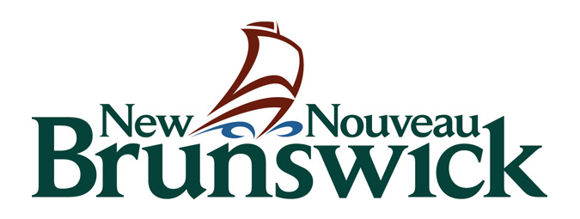

Department of Tourism, Heritage, and Culture

PUBLIC ART GUIDELINES – MAPLEHURST MIDDLE SCHOOL

OVERVIEW
The New Brunswick Department of Tourism, Heritage and Culture invites professional artists to submit proposals to design, create and install public artwork at the new Maplehurst Middle School in Moncton, NB. The total budget for commissioning public artwork at this site is $50,000. Once works are created and installed, they become part of collection ArtNB (formerly The New Brunswick Art Bank). Preference will be given to New Brunswick professional artists.

The application form can be found HERE.
The submission deadline for proposals is March 27, 2020 to culture@gnb.ca.
If selected, this commission has an installation deadline of December 31, 2020.

SITE DESCRIPTION
The Province of New Brunswick has constructed a new school at 320 Maplehurst Drive in Moncton. The middle school serves 58 staff and approx. 700 students in grades 6 to 8 and is comprised of students from Northrop Frye and Evergreen Park schools.

Maplehurst Middle School is a welcoming environment for all community members and values inclusion of diverse peoples and ideas, reconciliation and renewal of the relationship with Indigenous peoples and worldviews, equity among all people, plurilingualism, and pluriculturalism. The school values excellence and diversity in learning, wellness and community. Students aim to envision the impact they have on the world as a community. The school colours are grey with accents of gold and light blue. The school prides themselves in their community’s strength, hard work, intelligence and the willingness to function as a team.

ELIGIBILITY
The call to artists is open to professional artists. An individual artist or a group of artists may propose a project. Please refer to the full definition of ‘professional artist’ HERE.

A professional artist is defined as an individual who:
- Has a history of public presentation in a professional context;
- Practices an art and offers services in exchange for remuneration as a creator; and
- Has specialized training in the arts (not necessarily in academic institutions) and is recognized as such by their peers.

Ineligible:
- Submissions from students at any level are not eligible;
- Artists who are contract employees of NB Anglophone East School District are not eligible;
- Members of the Evaluation Committee, the GNB Steering Committee, and their immediate families are ineligible to apply.

POTENTIAL ARTWORK LOCATIONS
Please reference the Potential Locations Document HERE.
If you cannot access the above file, please contact the Public Art Coordinator.
Artists are encouraged to propose pieces for one or more of the common areas above or to propose alternate interior or exterior locations within school grounds. A site visit for interested artists will be scheduled and promoted prior to the submission deadline.

IMAGE GUIDELINES
- Preferred image format: JPG or PNG.
- Maximum image size: 2MB per image.
- If you wish to submit a video, animation or other new media, please contact the Public Art Coordinator to discuss options.
- Please note: the GNB email system has a 9MB limit. Send multiple emails if required. If sending video files larger than 9MB, please submit via Dropbox or WeTransfer.com to culture@gnb.ca.

PROPOSAL SPECIFICATIONS
- The artist(s) will be responsible for all expenses related to production and installation costs.
- Artwork must be of original design. The artist(s) owns all rights to what is used, and the artwork must not violate the copyright of any other person(s).
- If artwork is installed outside, the projected expenses must include all estimated costs of installation, including the building of a foundation if necessary.
- Artwork in any medium and in 2D or 3D will be considered. However, changes to the structure of the building (walls, ceilings) will not be considered. The artwork must be durable, low maintenance and appropriate to the location.
- Artwork must be constructed of long-lasting materials that can withstand non-museum light levels, temperature and humidity conditions. If artwork is installed outside, materials should withstand long-term weather conditions.
- Artwork must not have any sharp edges and no film is permitted on glass surfaces (i.e. interior windows, doors, etc.).
- Safety is of the utmost importance. The artist is responsible to ensure artwork meets all local building and fire codes, including but not limited to flame and smoke spread rating, sprinkler coverage, egress widths, etc. Based on fire regulations, artwork must not be suspended from the ceiling, as materials could impede sprinklers.
- No modification to the building will be accepted in the installation of the public art.

SELECTION PROCESS
- The GNB Steering Committee will review all submissions for eligibility. The Steering Committee is composed of representatives from the Departments of Education and Early Childhood Development, Transportation and Infrastructure, and Tourism, Heritage and Culture.
- Following review of proposals, an Evaluation Committee will review the submissions and determine which shortlisted artists to invite to present more detailed proposals and to attend a site visit. The Evaluation Committee is composed of the following voting members:
- A professional artist;
- Representatives from the School District; and
- Parent representatives.
- The shortlisted artists selected for the second round will receive a design fee for refining their proposals. Final proposals may include detailed models, drawings, renderings, samples of work and/or materials depending on the nature of the proposal. Finalists will be invited to present their final proposals to the Evaluation Committee in person, by conference call, or Skype (to be determined).

QUESTIONS
All questions should be directed to Public Art Coordinator, Claire Gulliver:
Claire.Gulliver@gnb.ca (THC) or at 506-444-5355.

